School of Transportation Burnaby Dept. App

(SoTBy)

Client Handoff Documentation

Group V5

Daniel (Bong Hyun) Chung

Sam Khademolhosseini

Timothy Tan

Maximilian Wu

# Table of Contents

**Table of Contents** **2**

**Installation & Starting the app** **4**

**Overview** **5**

Schedule Timeline: 5

Detailed Schedule: 5

Resources: 5

Login: 5

Create User: 5

Create Course: 5

Create Resource: 6

Vacation Request Form: 6

Vacation Approval Page: 6

**App Usage** **7**

Schedule Timeline: 7

User interface 7

Usage 7

Login: 10

User interface 10

Usage 10

Create User 11

User Interface 11

Usage 12

Create Course 12

User Interface 12

Usage 13

Create Resource 13

User Interface 13

Usage 14

Vacation Request Form 15

User Interface 15

Usage 16

Vacation Approval Page 17

User Interface 17

Usage 18

Detail Schedule Page 18

User Interface 18

Usage 20

Resources Page 21

User Interface 21

Usage 22

# Installation & Starting the app

This section has been moved to the “Deployment Notes” document. Alternatively, you can take a look at the Project Handoff’s version of the deployment notes for a more technical explanation.

# Overview

The School of Transportation Burnaby Department App (SotBy) is an app designed to make scheduling of instructors and resources easier with the usage of live editing and a database. In this document, features of the app will be explored so that clients would be able to use the app.

### Schedule Timeline:

The timeline page is the main page where instructors can view courses, users and vacations for the entire year.

### Detailed Schedule:

If a user clicks on the detailed button on a course on the timeline, they will be redirected to the detailed schedule page. This page will display resources and instructors assigned to a course on a day-by-day basis.

### Resources:

From the detailed schedule page, you can go to the resources page by clicking the book button. On this page, you can book new resources, and also see how many of each resource is still available to be booked.

### Login:

The login page is where instructors can login as either a user or admin. Admins can perform more actions while users are limited to less.

### Create User:

The Create User page is an admin-only page where admin users can create new instructors and admin users. The information inputted by the user is posted to the database via sockets.

### Create Course:

The Create Course page is an admin-only page where admin users can create new courses to be assigned to instructors. The information inputted by the user is posted to the database via sockets.

### Create Resource:

The Create Resource page is an admin-only page where admin users can create new resources to be booked by instructors. The information inputted by the user is posted to the database via sockets.

### Vacation Request Form:

The vacation form submission page is where instructors can submit vacation requests. After submitting the form, the request shows up on the admin’s request approval page for processing. If the request is approved, it will appear on the schedule timeline page.

### Vacation Approval Page:

The vacation approval page is an admin-only page where admins can view the vacation requests made by users and either approve or reject them.

# App Usage

The following section will be on how to use different features of the app.

## Schedule Timeline:

### User interface

Upon opening the app, you should be greeted with this page

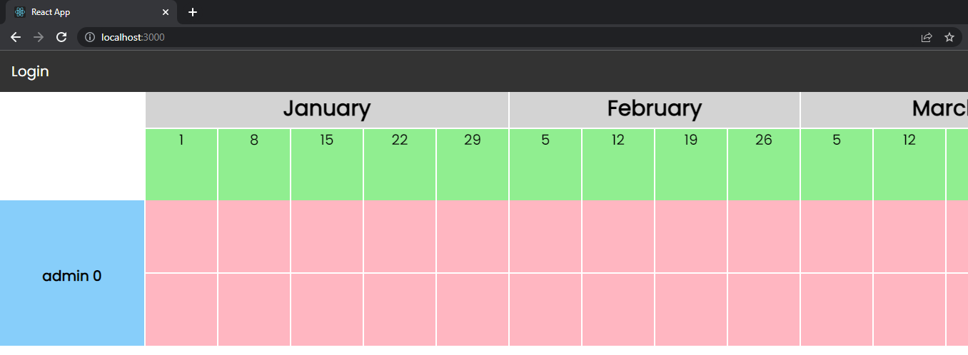

This page is the Schedule Timeline page which consists of an overview of instructors, the courses they are teaching and their vacations.

The first row for each instructor is the course row. This row would be the courses the instructor is teaching. The second row is for the vacations that the instructor may have.

To be able to edit the timeline, click on the Login button on the top left of the navigation bar. An admin user is automatically created for you and the following are its credentials:

Username: admin_0

Password: password

### Usage

Upon logging in, you should see new buttons at the top of the navigation bar. These buttons are operations that modify the data in some way. You can click on them to navigate to another page to perform the corresponding operations.

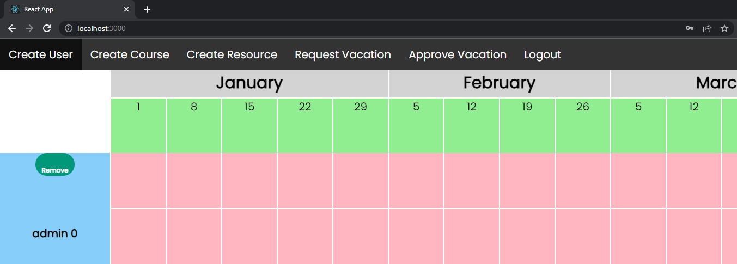

Also on the timeline are operations for removing a user and creating a course. The remove button above the instructor’s name is to remove the user from the app all together.

To create a course, click on the Create Course button and enter in the required fields. After, you can click on any grid square on the first row of any user and you can now assign a course to that user.

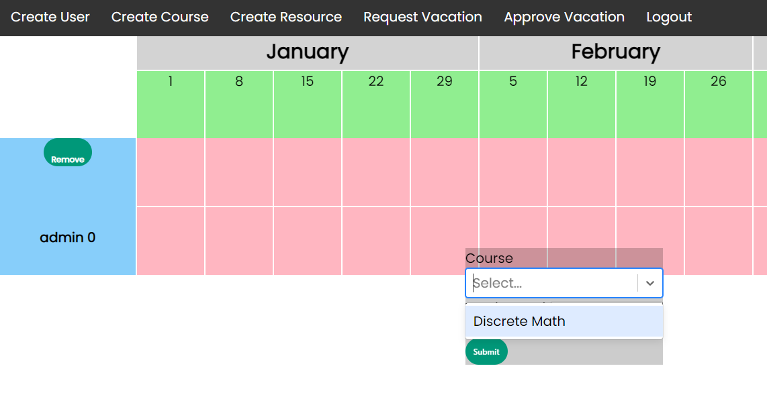

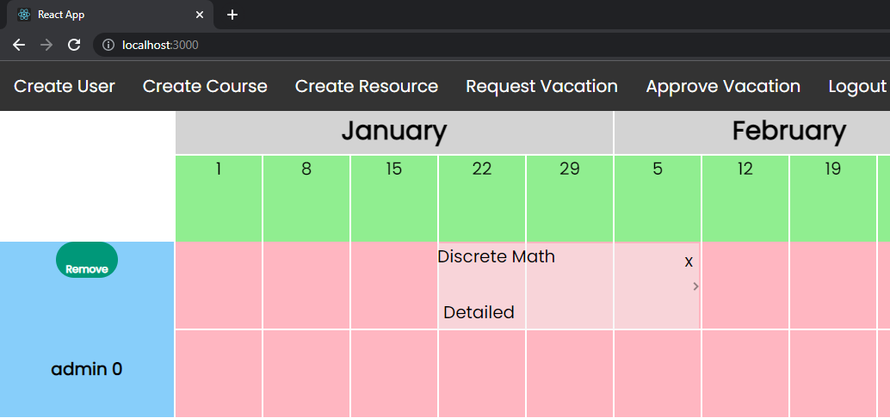

After a course is created, a course element would be created on that row. The following are the operations you can perform with a course element:

* To move this course element, click anywhere but the “Detailed” and the “x” and drag.
* To resize this element, click on the arrow on the right and drag.
* To view more about this course assignment, click on the “Detailed” text of the course element.
* To remove this element, click on the “x” on the top right of the element.

Vacations can also be created and displayed on the timeline page however unlike the course elements, they can only be deleted and not moved.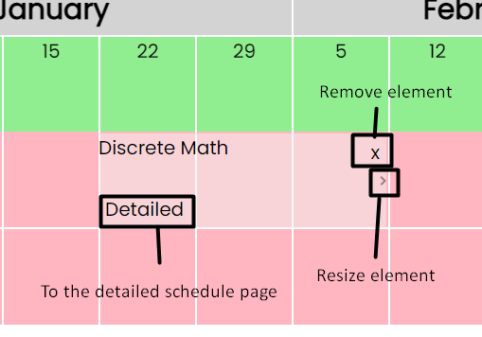

Please note that if the admin user is deleted, there is no way of logging in again so ensure that there is at least one Admin level user created at all times.

## Login:

### User interface

All users have access to the login page from the main Schedule Timeline page. Depending on the users’ admin status, they will either be logged in as an instructor or an admin.

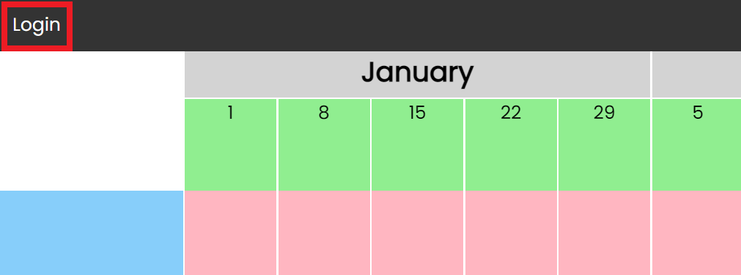

Click {Login} to access the login page.

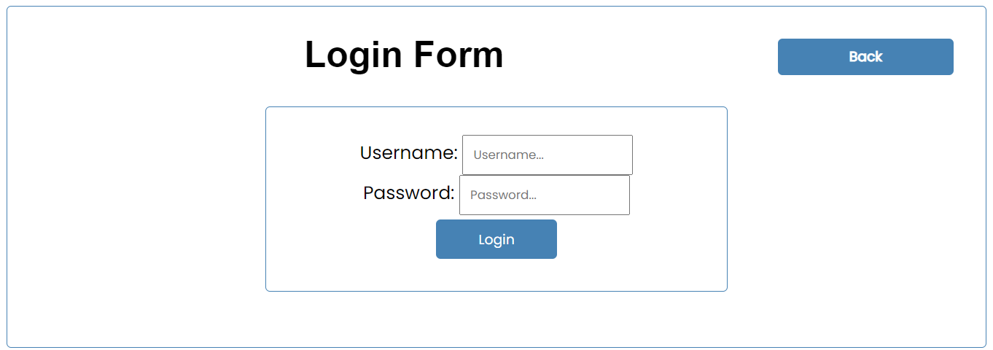

### Usage

Enter your username and password in the corresponding fields. If you just created your database, then the default admin’s username should be “admin_0” and its password should be ”password”. Then click {Login}. Upon successful login, you will be taken back to the Schedule Timeline page.

## Create User

### User Interface

To access the Create User page, you must first login to an admin’s account. Once you’ve logged in, the {Create User} option will become available in the navigation bar.

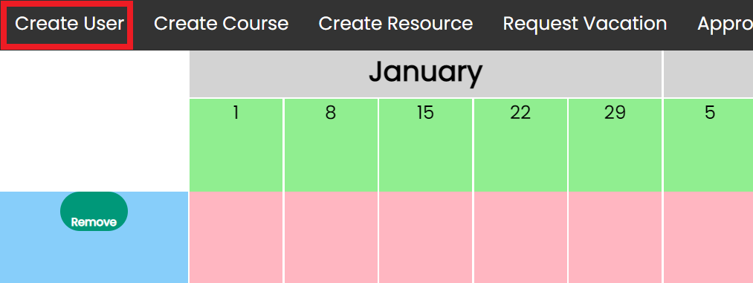

Once you’ve clicked the option, you should see something that resembles the following image:

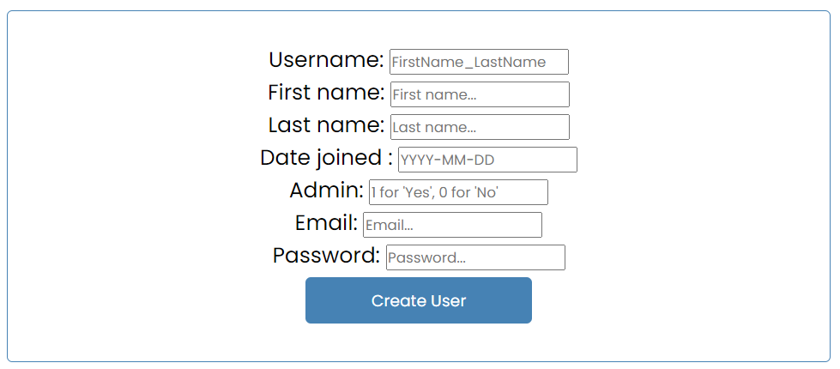

### 

### Usage

Fill out the fields appropriately. Click the {Create User} button to add the user to the database. If the user has been successfully created, the following message will appear:

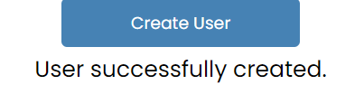

## Create Course

### User Interface

To access the Create Course page, you must first login to an admin’s account. Once you’ve logged in, the {Create Course} option will become available in the navigation bar.

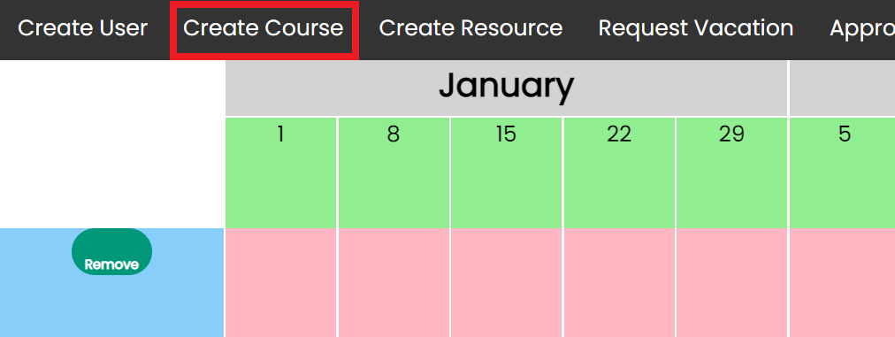

Once you’ve clicked the option, you should see something that resembles the following image:

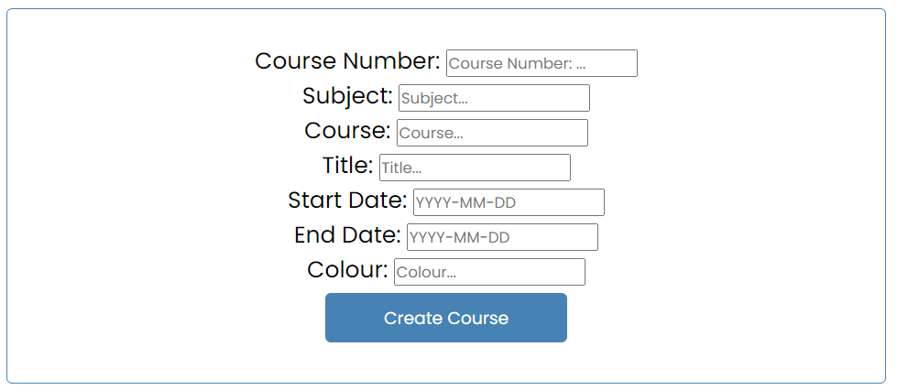

### Usage

Fill out the fields appropriately. Click the {Create Course} button to add the user to the database. If the course has been successfully created, the following message will appear:

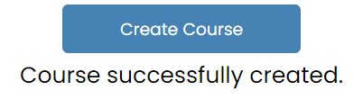

## Create Resource

### User Interface

To access the Create Resource page, you must first login to an admin’s account. Once you’ve logged in, the {Create Resource} option will become available in the navigation bar.

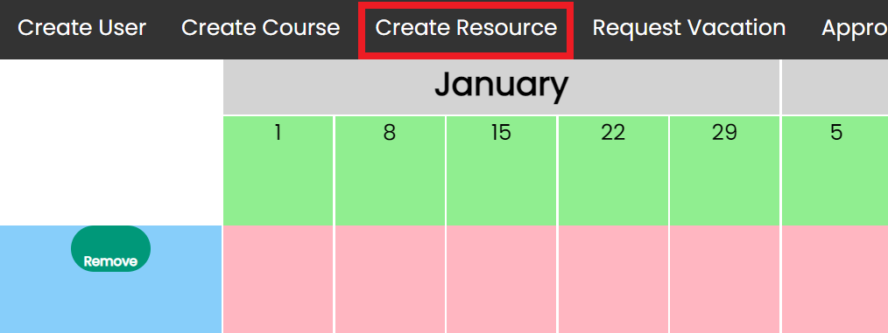

Once you’ve clicked the option, you should see something that resembles the following image:

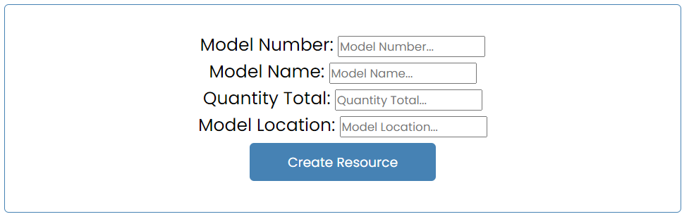

### Usage

Fill out the fields appropriately. Click the {Create Resource} button to add the user to the database. If the resource has been successfully created, the following message will appear:

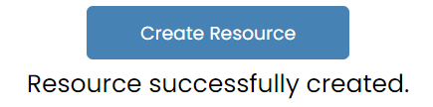

## Vacation Request Form

### User Interface

To access the vacation request form, you must first login to your account. Once you’ve logged in, the {Request Vacation} option will become available in the navigation bar.

Admins:

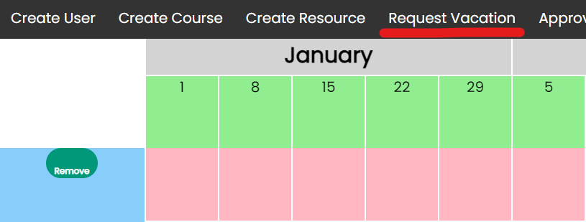

Non-admins:

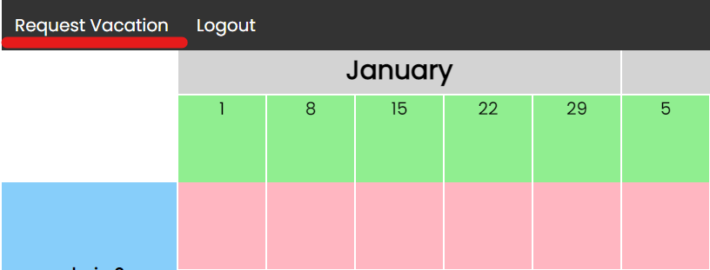

Once you’ve clicked the option, you should see something like this:

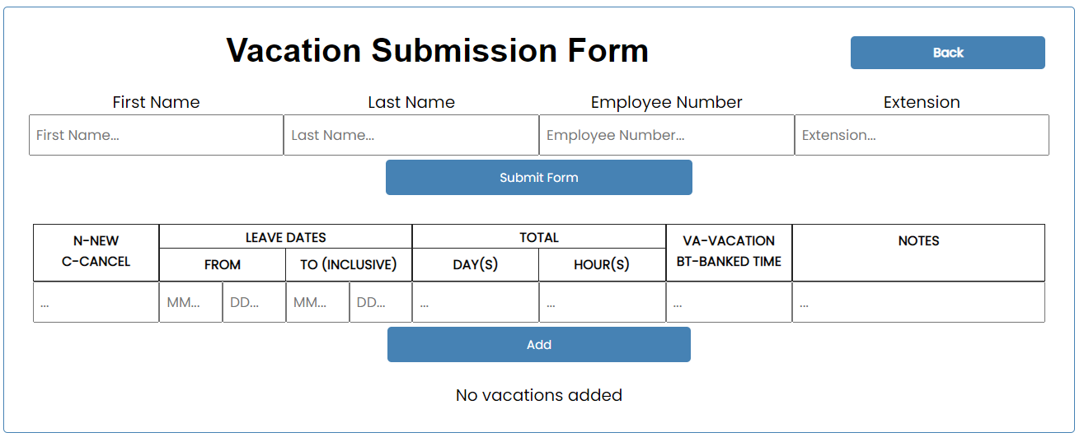

### Usage

The top inputs are for the user’s information. The bottom inputs are for the vacations. For each vacation, fill out the row of input using the labels as a guide. Click the {Add} button to add the vacation. You should see all your added vacations underneath.

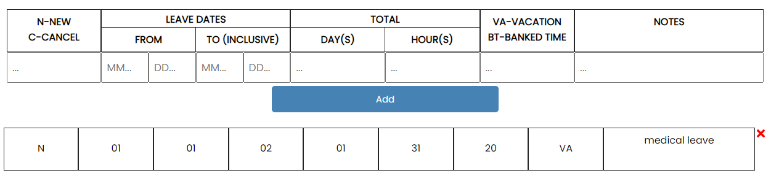

Once you’ve added all the vacations, click the {Submit} button to submit the request form.

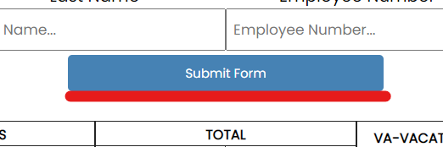

If the form has been successfully sent, there should be a display message.



## Vacation Approval Page

### User Interface

To access the approval page, you must first login to an admin’s account. Once you’ve logged in, the {Approve Vacation} option will become available in the navigation bar.

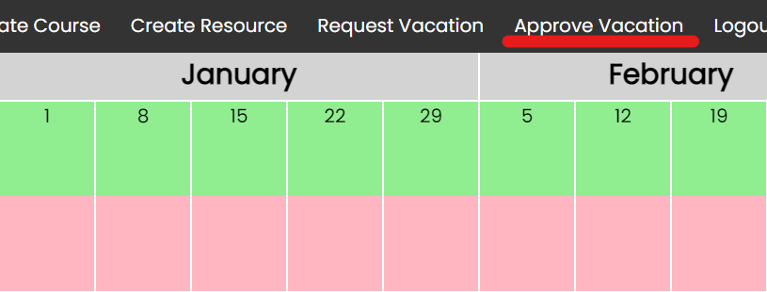

Once you’ve clicked the option, you should see something that resembles the following images:

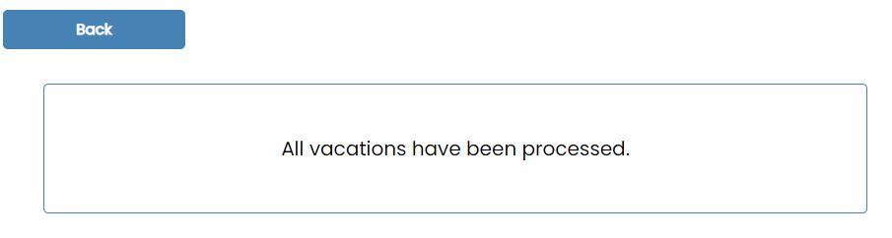

This display message indicates that there are currently no requests to be processed.

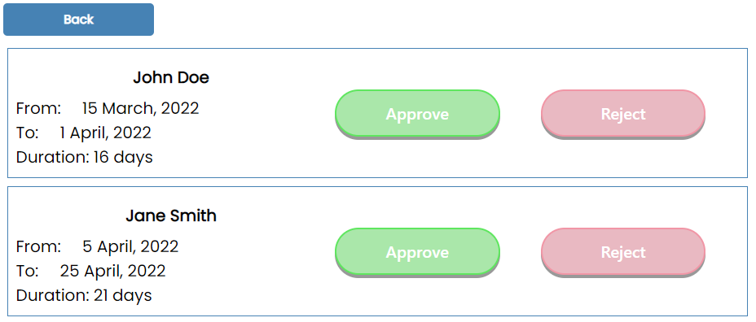

This page shows that there are requests that need to be processed.

### Usage

Each request has the requester’s first name and last name followed by the details of the vacation request. On the right side of each request are two buttons: approve and reject.

Clicking the {Approve} button will have the vacation automatically appear on the schedule timeline. Clicking the {Reject} button will have the vacation removed from the database.

Note:

This vacation approval page uses sockets. If there are multiple admins processing requests, the processed requests will be removed from this approval page for all admins in real time.

## Detail Schedule Page

### User Interface

To access the detailSchedule page, you must first login to an account. Once you’ve logged in, the {detailed} option will become available on each course displayed on the main timeline page.

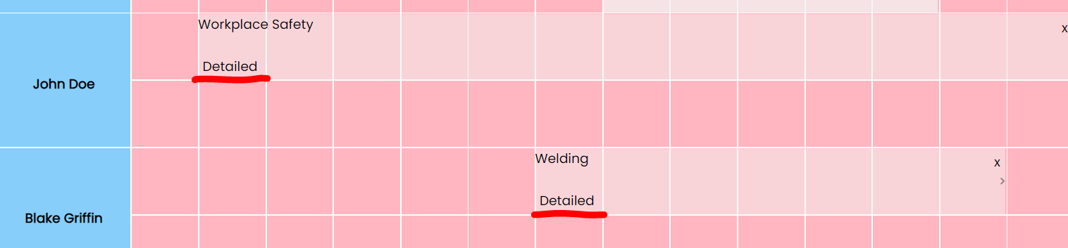

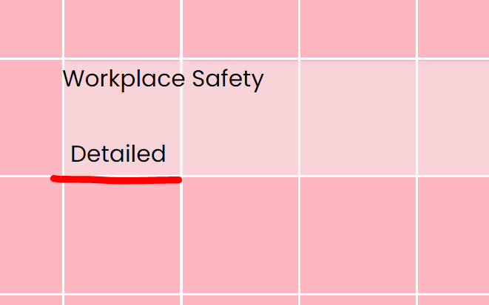

Once clicked, you should be redirected to the detailed schedule page and you should see something like this:

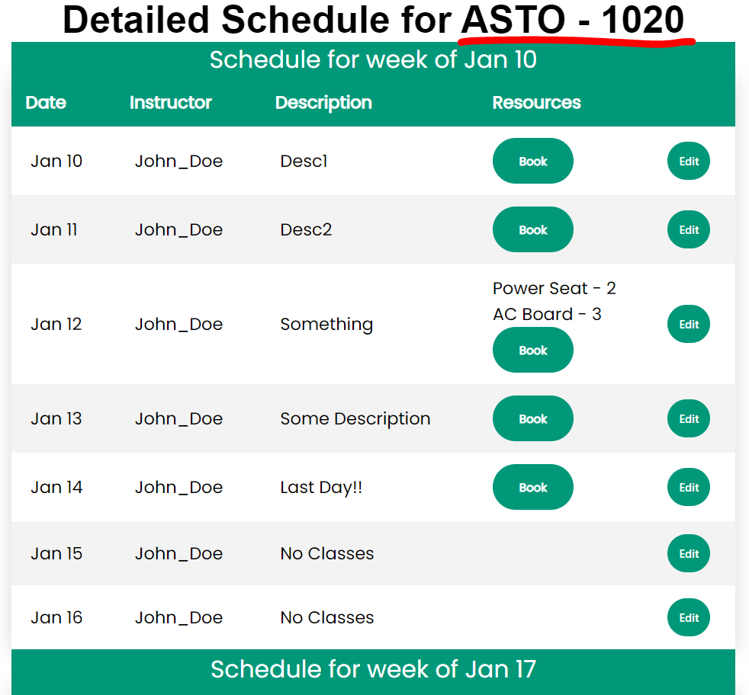

### Usage

Main purpose of this page is to be able to see more information about the selected course.

However, you can also change the description of a day. If that’s the case, you need to do the followings:

Once you are on the detailSchedule page, you can click on the {edit} button to make the description field of that row editable.

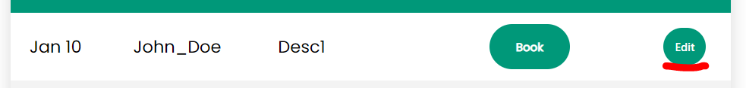

Then you can edit the description of this day (in this example, Jan 10), by clicking on Desc1 and entering the new description. Then you need to click {save}.

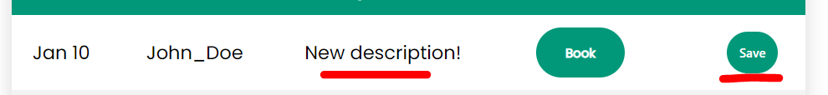

Then the save button should change back to edit, and you can edit again if you want.

Note that this page supports live editing, meaning that if a user makes a change all other users on the page can see the changes without needing to reload the page.

## Resources Page

### User Interface

To access the resources page, you need to be on the detailSchedule page. In case you do not know how to get there, please follow the instructions under

Detail Schedule page -> User Interface

Note that a day needs to have a description in order to be able to book resources for it. (otherwise we assume there aren't any classes planned for this day).

Once you are on the detailSchedule page, you should be able to see a book button in each row (that already has a description). Click on the {book} button.

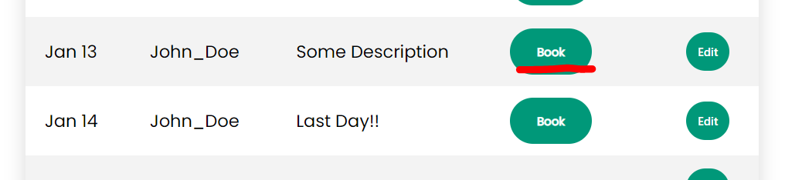

Then you will be redirected to the resources page for that day, and you should be able to see a page similar to this:

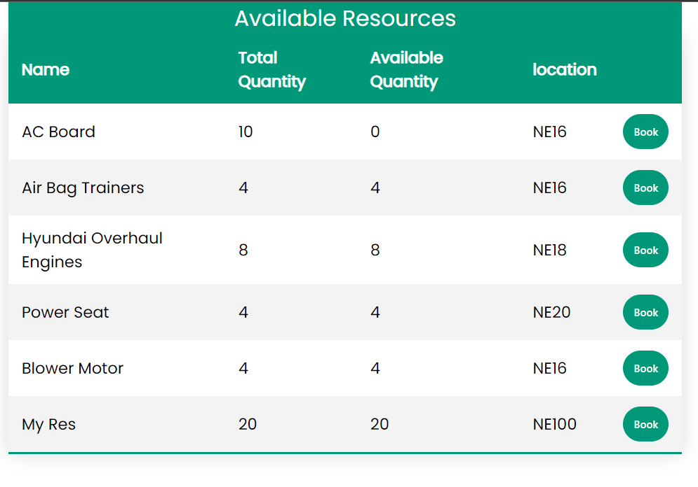

### Usage

Once you are on a resources page, you can book a resource for that day by following the instructions below.

Find the resource you want to book. Click on the {book} button.



You should be able to see a form that asks you how many of that resource you want to book.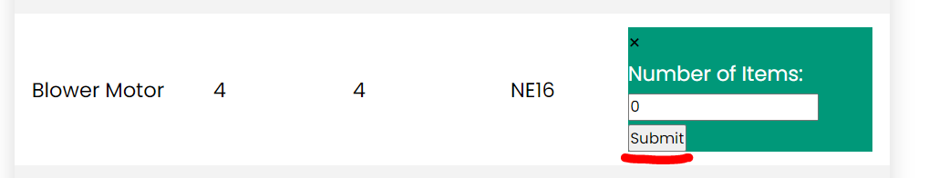

Enter a number and click submit.

Based on the number you put, you get different results as displayed below:

* Successful -> If enough quantity is available.  
  And you will get this message.  
  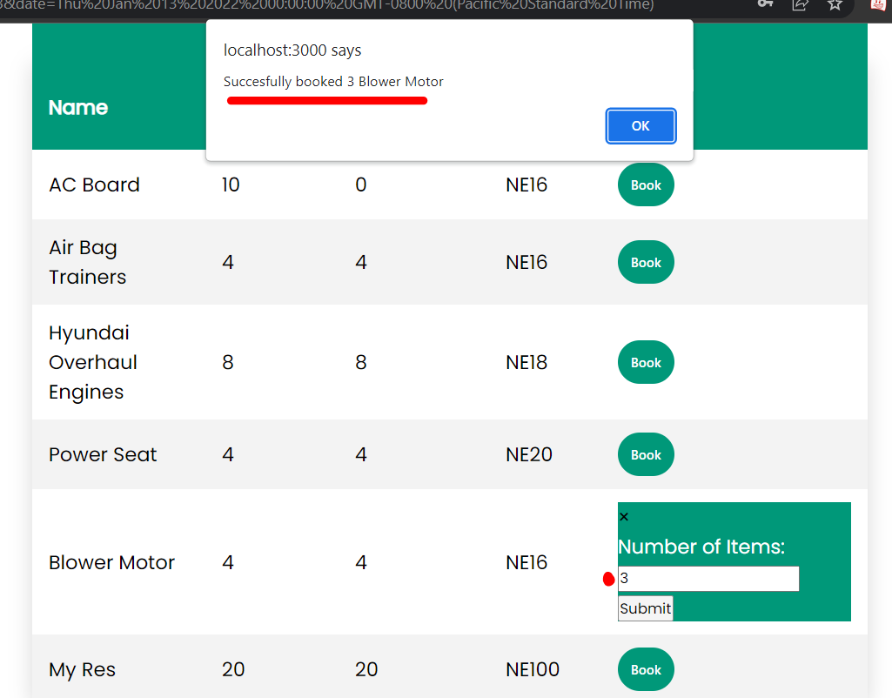  
  And you will see the quantity_left column gets updated.  
  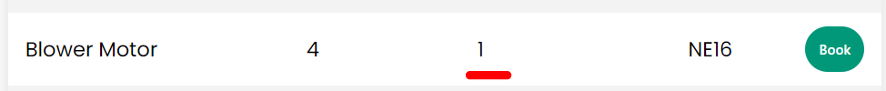
* Unsuccessful -> if you try to book more than the number available. (more than quantity_left)  
  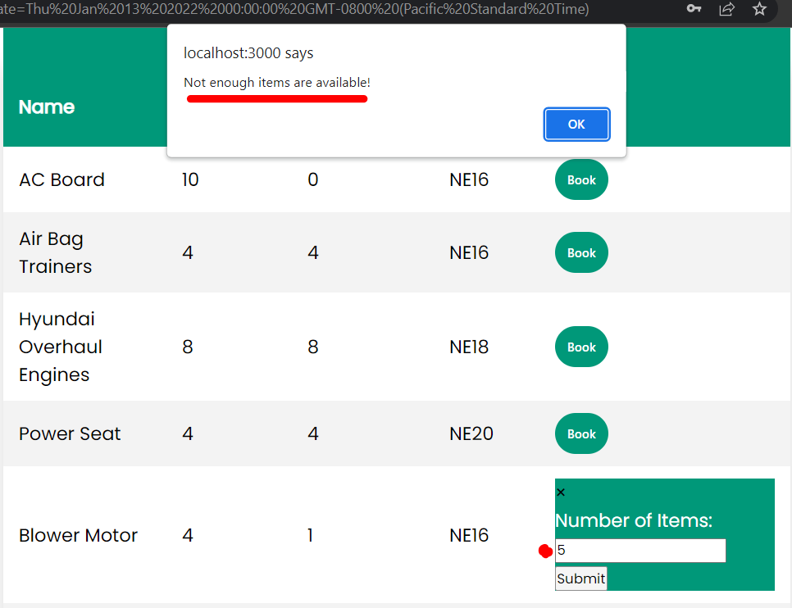
* Unsuccessful -> if you enter a negative number, or characters instead of numbers. And you will get different error messages for them.

Note that this page supports live editing, meaning that if a user makes a change all other users on the page can see the changes without needing to reload the page.

Now that you have successfully booked a resource, you can see it on the detailSchedule page.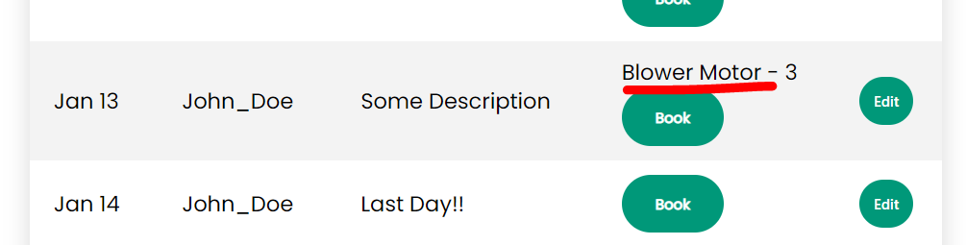

You can repeat these steps to book resources for other days or even the same day again.